===============================================================

Jenkins Installation

===============================================================

docker run --name Jenkins -p 8080:8080 -p 50000:50000 -v jenkins_home:/var/jenkins_home jenkins/jenkins

Password Eg:- [ Password:- 8be4e7d78e984bd09a5868926b172bb1 ]

--------------------------------------------

Login URL:- http://localhost:8080/

Password:- 8be4e7d78e984bd09a5868926b172bb1

--------------------------------------------

Click on-> Install Suggested Plugin

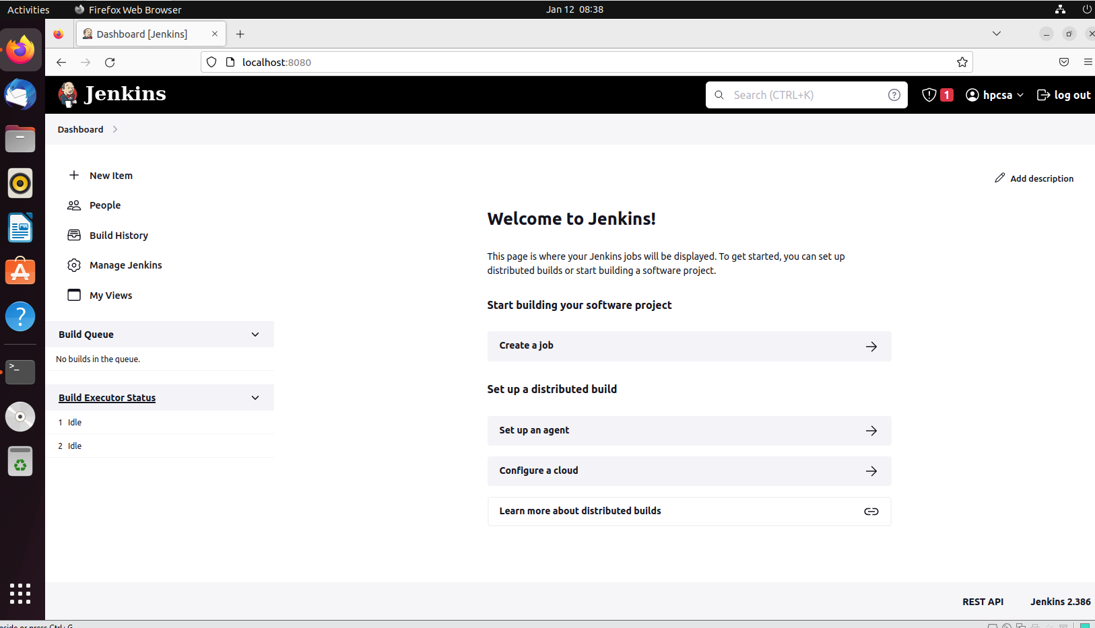

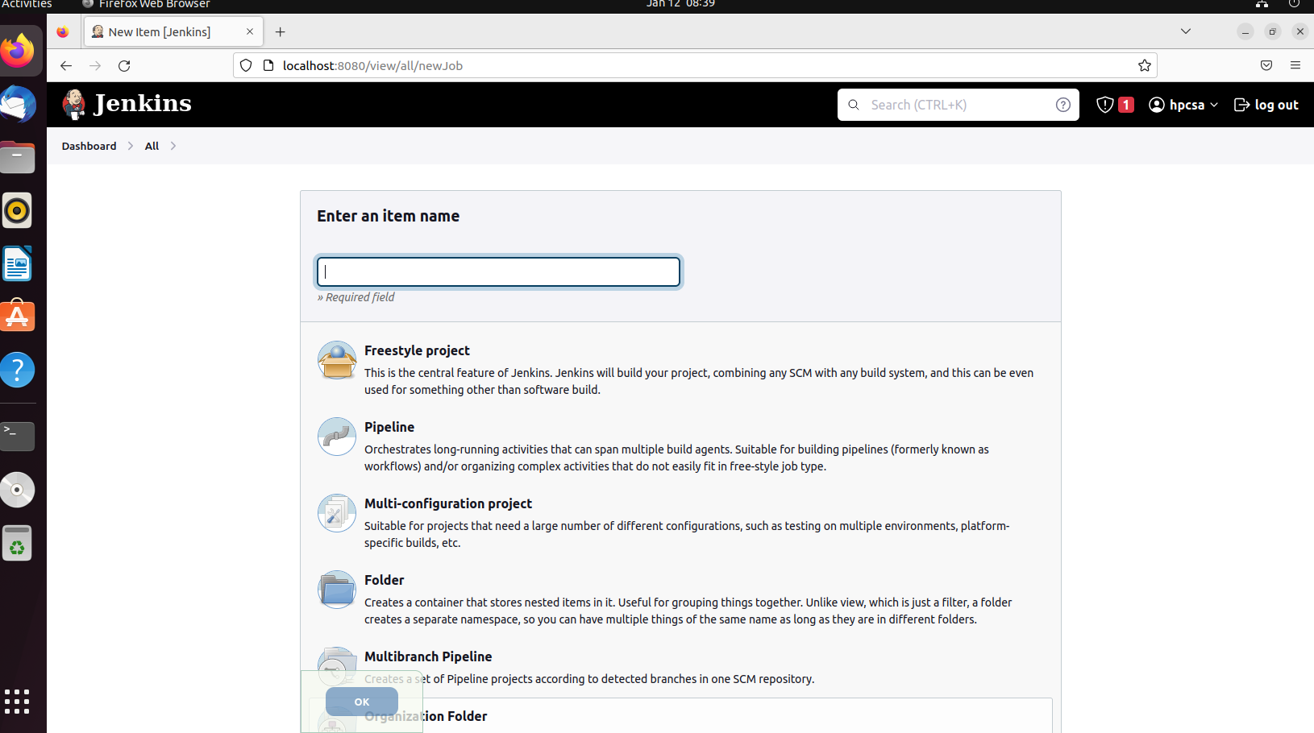

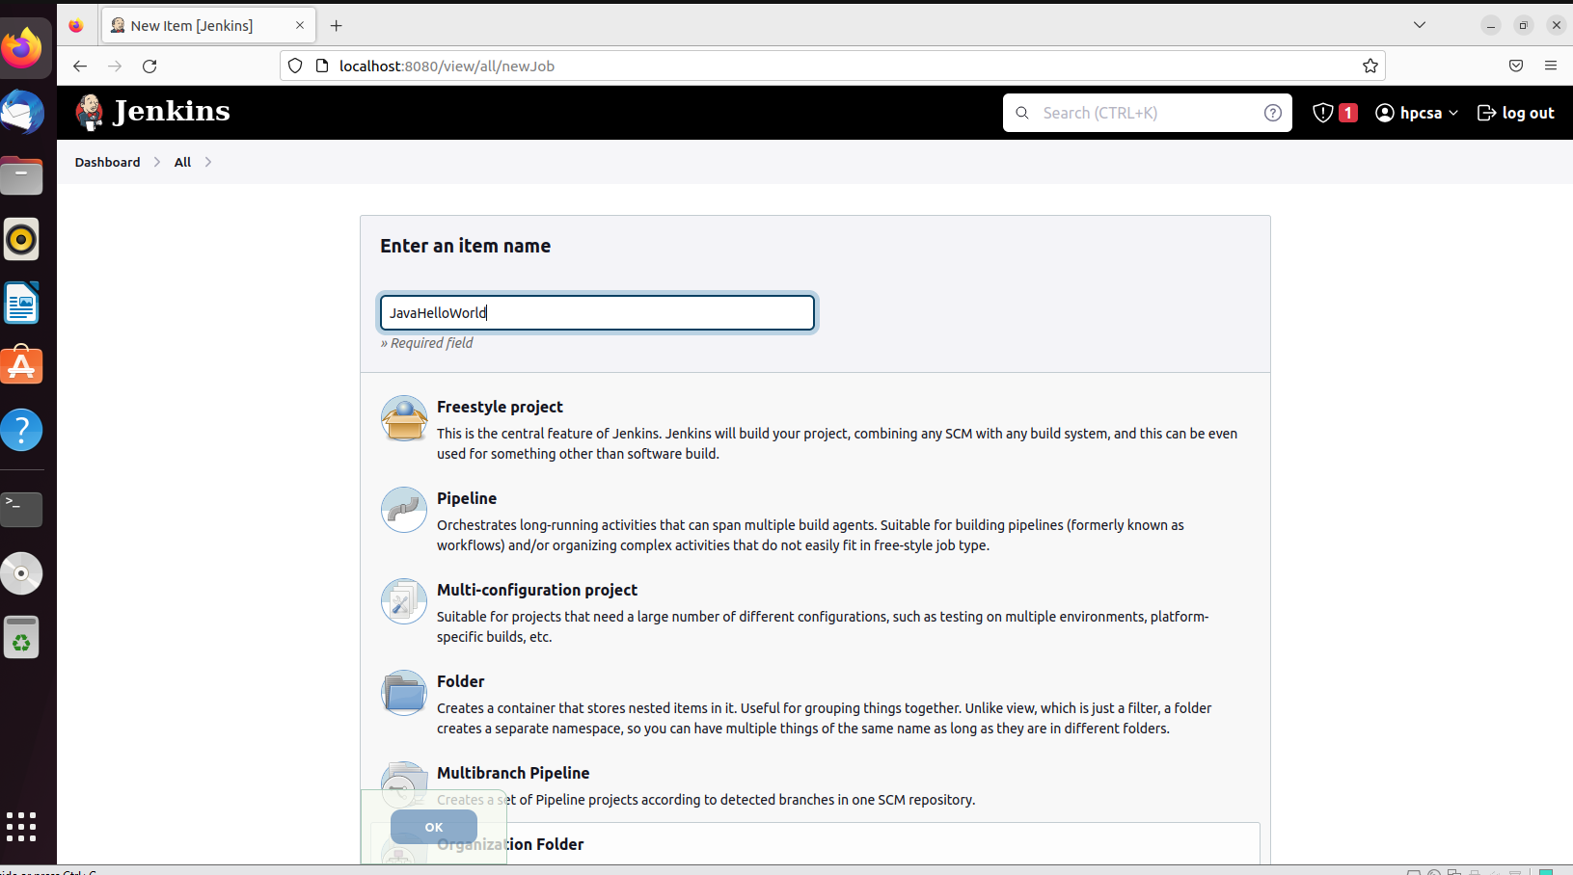

Select freestyle & ok

